**Task 3 Development – Tom H**

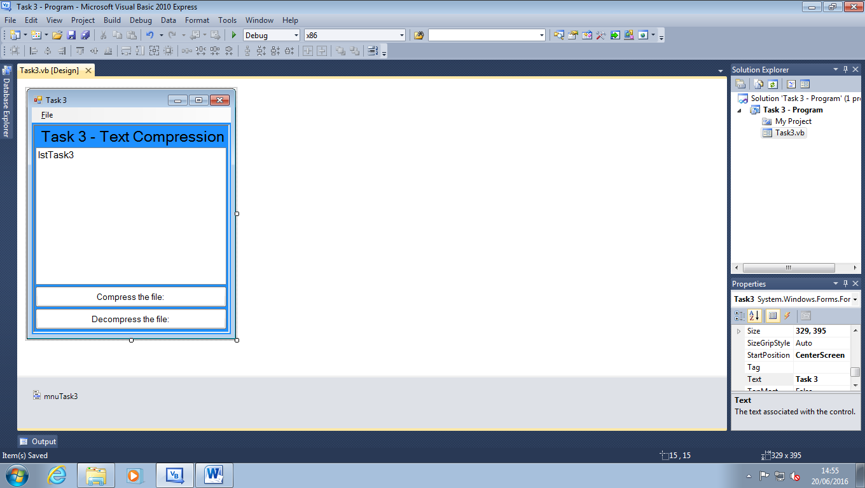

I have developed my user interface to look user friendly and efficient. The items onscreen, such as the list box and the buttons are anchored so resize with the program. I also implemented a menu strip for secondary commands that I see little purpose of displaying on the main form.

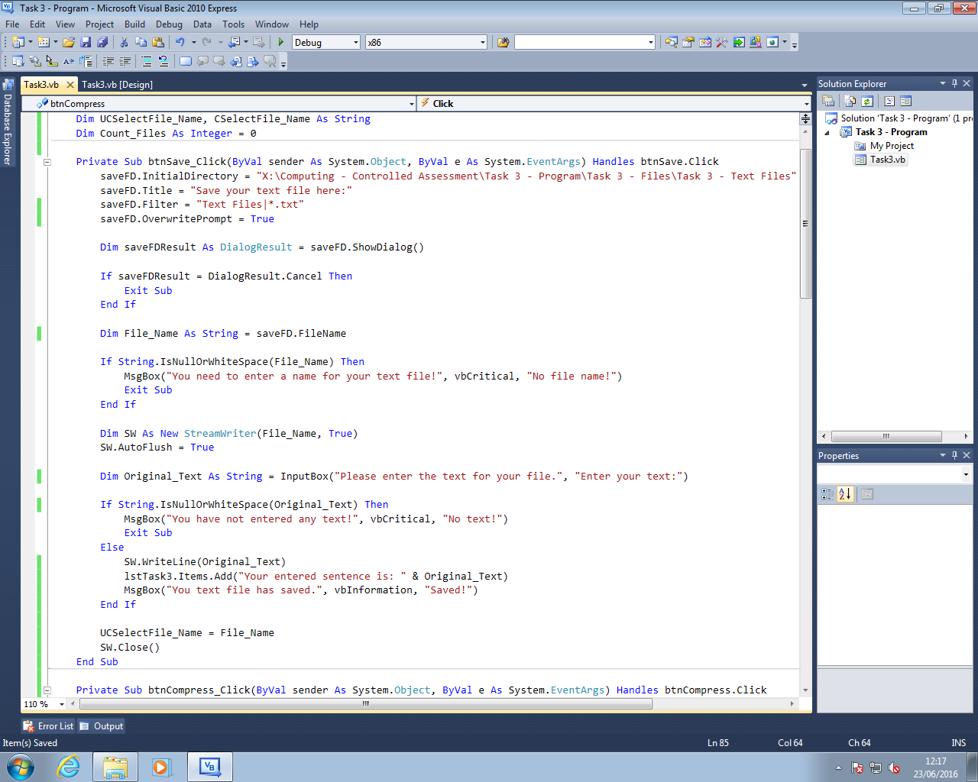

I have programmed the first major part of my code. It saves a file with the text that the user has entered. I added a lot of validation as this is an area in particular that could through up a lot of errors.

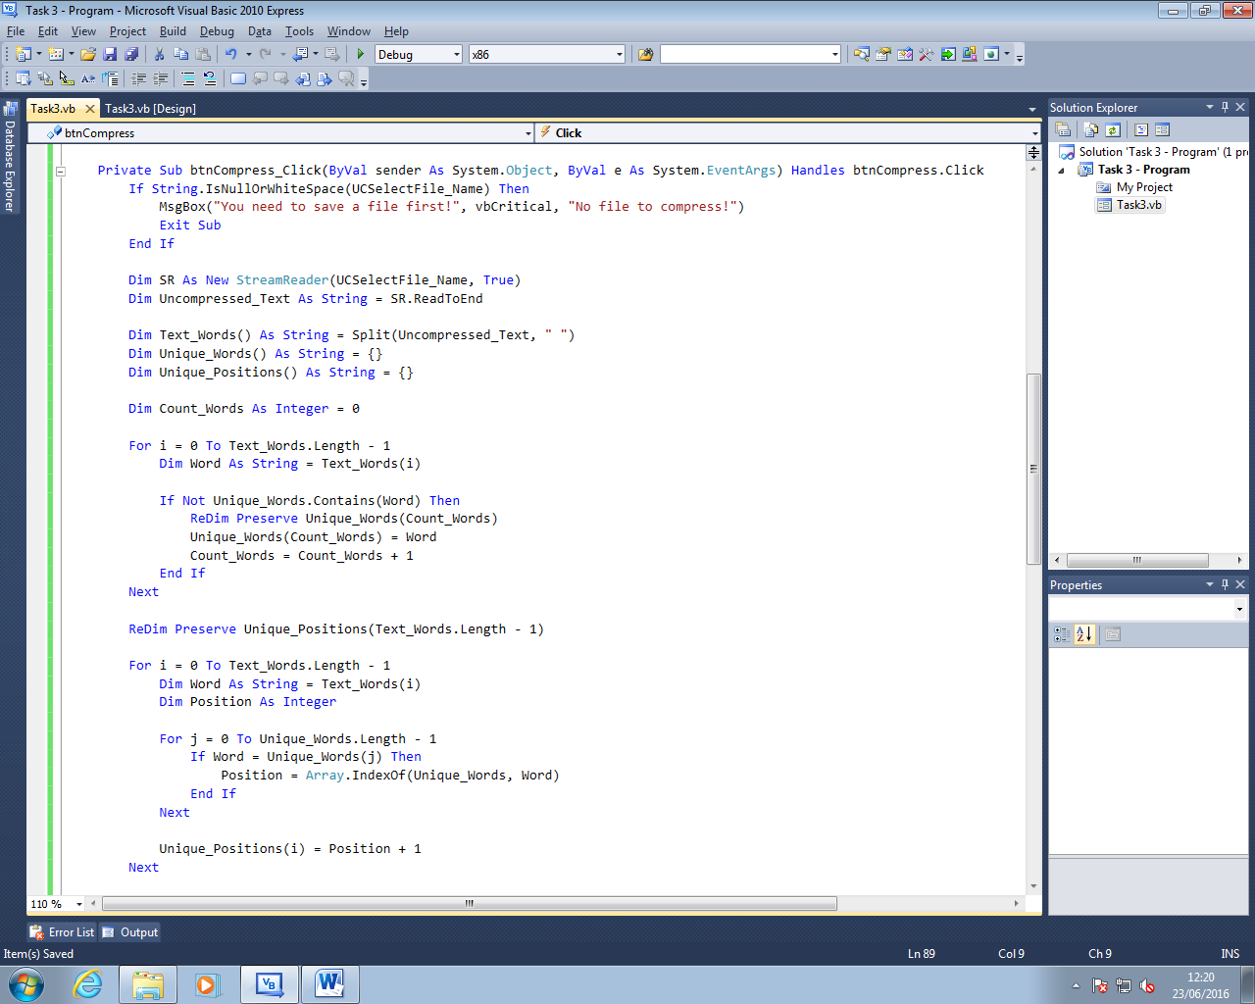

I have added the compression that I used in task 2, with the only difference being it reads the text from a text file rather than an array from within the program itself.

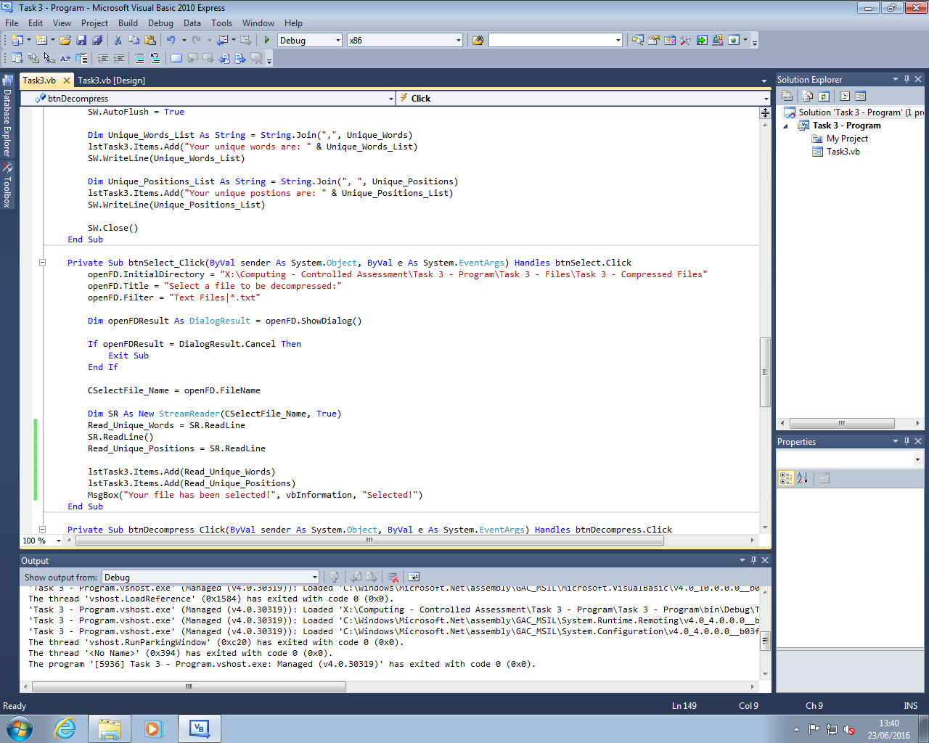

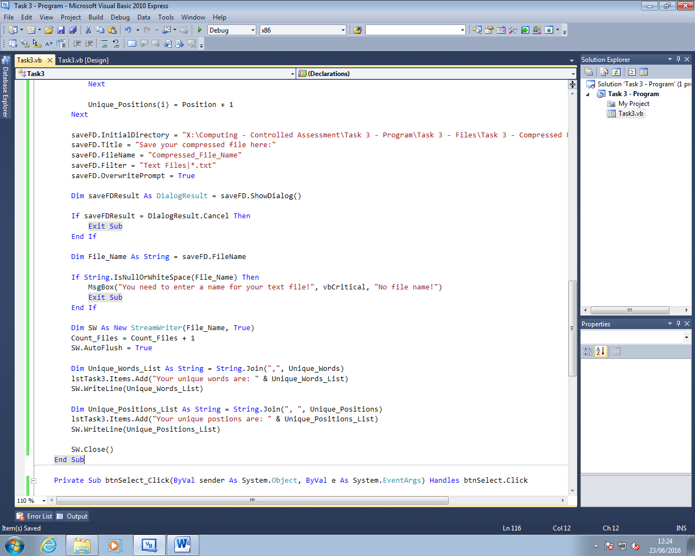I have added in a part of code that reads a selected, pre-compressed file and creates it into a string. I did this by adding a stream reader and an open file dialog that opens takes the name of a selected file.

I have added in the code for saving the compressed sentence to a text file in a separate folder. It also has a fair amount of validation because it’s saving a file.